 | Disabled American Veterans, Department of Maryland,Inc.  Newsletter | Tel # 410-539-1310  Fax # 410-539-2106  Email Address: dav_md@verizon.net  1st DEC–10/21/07 1PM  American Legion, # 11  1450 Taney Avenue  Frederick, MD 21702  Tele # 301-662-9345  Year 2007-08 Issue 1  Dated: Sept. 2007  Publisher: B. Iafolla

This Newsletter is dedicated in memory of Leonard R. Rencher,
Department Adjutant and his service to the DAV, Department of

Commander Message:

I wish to thank each of you for the kindness shown at the death of our Adjutant Leonard R. Rencher. Adjutant Rencher was a hard worker, dedicated to serving veterans and their families. We miss him and pray daily for his family. May God Bless You!

If you ever need to contact me, I can now be reached on the Department Cell Phone instead of my personal cell phone. Please use the Department Cell Phone number 410-207-0978 when trying to reach me.

I am constantly reminded of the many things so many of you do to insure that veterans and their families receive the benefits promised them. Without your support and caring attitudes so many veterans would not receive first class medical treatment and other government benefits. It is the little things we do that count. Continue the hard work and make the DAV, Department of Maryland the very best. I cannot thank each of you enough for your volunteer efforts dedicated to improving the lives of veterans and their families. It is especially heartwarming to know that so many give freely of their time so others may share in the benefits available to them. I am eternally thankful to each of you who have volunteered to serve on the committees; because of your willingness to serve we have filled each of the committees.

It was gratifying to see the attendance at our meeting of the committee chairpersons, past department commanders, hospital service coordinators, and volunteer drivers on the 25th of August. It goes without saying how pleased we were to see the Disabled American Veterans Auxiliary (DAVA) Commander, the DAVA Adjutant, Past DAVA Commanders, and other Auxiliary members at the meeting. Many thanks to Senator Doug Peters for coming to the meeting and giving us advice on bills regarding veteran benefits on the State level. It is meeting such as this that we share ideas, and develop means of making the Department of Maryland better. Again I say thank you.

A highlight of the year was the Drive Away from Perry Point on July 18, 2007. The five vans were donated by the DAV, Department of Maryland to various Veteran Affairs Medical Centers and Clinics within the State of Maryland. I am pleased to offer a special thanks to Past Commanders Bamberger, Mitchell and Ferguson, the National Headquarters and everyone who worked to make the Drive Away possible.

We are now working to make the first Department Executive Committee Meeting on October 21, 2007 a success. I encourage everyone responsible for a report(s) to complete it/them and get them to the department early before October 5th. It is especially important to get the reports in early because we are understaffed.

Along with your DEC reports, I wish to remind each chapter commander to insure that their financial report is completed and forwarded to the National Headquarters and/or the Department of Maryland by the deadline of September 30, 2007.

I encourage each of the Chapters to take advantage of the fundraising opportunity offered by Forget-Me-Not. The Forget-Me-Not fundraiser provides us an opportunity to acquire funds for service to veterans and their families and to talk with them about benefits available to them.

Thank you for your support and May God Bless Each of You.

Sincerely,

Glynn E. Parker
Commander
DAV, Dept. of Maryland

MAY THERE BE
PEACE IN THE WORLD

IMPORTANT PHONE NUMBERS

Nat’l. Hdqrs., DAV (877)426-2838
DAV, Dept. of MD (410)539-1310
(800)328-6953
NSO Office – Baltimore (410)230-4440
NSO Office –Wash., DC (202)530-9261
VA Regional Office –Balto. (410)230-4500
(800)827-1000
VA Regional Office – DC (202)530-9260
Dept. of Veterans Affairs (800)446-4926
VAMHCS – Baltimore 1-800-463-6295
DAV Transportation (410)605-7000
HSC, Toni King (Ext. 6733)
BRECC (410)605-7000
VAMHCS – Perry Point 1-800-949-1003
DAV Transportation (410)642-2411
HSC, George W. Mitchell (Ext. 5384)
VAMC – Cambridge (410)228-6243
VAMC – Cumberland (301)724-0061
VAMC - Fort Howard 1-800-351-8387
DAV Transportation (410)477-7050
HSC, (Ext. 7019)
VAMC – Greenbelt (301)345-2463
VAMC – Loch Raven 1-800-463-6295
VAMC – Charlotte Hall (301)884-7102
1-800-522-8387
VAMC – Hagerstown (301)665-1462
VAMC – Glen Burnie
DAV Transportation (410)590-4140
HSC, Tommie Hawkins (Ext. 4221)
VAMC – Pocomoke 1-877-864-9611
VAMC – Washington, DC (202)745-8100
VAMC - Wilmington, DE (302)633-5414
VAMC – Martinsburg, WV (304)263-0811

Telephone Care Line: To schedule Urgent Care Appt. call 1-800-865-2441

Prescription Refill Line: 1-800-463-6295,ext 7395
Have SS# & Prescription # ready, press option “2”
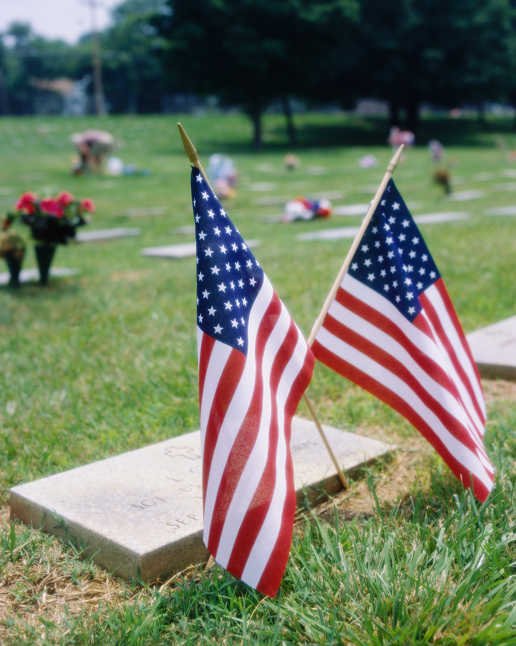
CEMETERY & MEMORIAL PROGRAMS
Robert L. Hooper III, Director
1122 Sunrise Beach Road
Crownsville, MD 21032
Anne Arundel County
410-923-6981

CHELTENHAM VETERANS CEMETERY
Martin F. Fahey, Superintendent
Cheltenham
Prince George’s County
301-372-6398

CROWNSVILLE VETERANS CEMETERY
Christopher T. Piscitelli
Superintendent
Crownsville
Anne Arundel County
410-987-6320

EASTERN SHORE VETERANS CEMETERY
Bruce W. Webster, Superintendent
Hurlock
Dorchester County
410-943-3420

GARRISON FOREST
VETERANS CEMETERY
Kenneth McKisser, Superintendent
Owings Mills
Baltimore County
410-363-6090

ROCKY GAP VETERANS CEMETERY
Ronald B. Platt, Superintendent
Allegany County
301-777-2185

MEMORIALS
Patrick M. Tracy, Superintendent
Baltimore, MD
410-354-3550

WAR MEMORIAL BUILDING
(WWI & II records, service metals)
Douglas W. Henley
Executive Director
Baltimore
410-396-8013
UPCOMING EVENTS
(DATES TO REMEMBER)

September, 2007
Forget-Me-Not Month – All Chapters

3 Labor Day (Department Office Closed)

8 (MSO) Ft Washington, Harley Davidson
9407 Livingston Road, 10-4 PM

9 (MSO) Williamsport, Harley Davidson
10210 Gov. Lane Blvd # 2004, 11-4 PM

11 (MSO) Westminster, VFW Post 467
519 Poole Rd., 11-4 PM

12 Rosh Hashanah (Sundown)

13 (MSO) Frederick, AmVets Post #2
702 East South Street, 11-6 PM

16 Auxiliary Past State Commanders
Crab Feast – 1 PM at Bowie Chapter Home
Tickets $25.00

18 (MSO) California, Wal Mart Parking Lot
45485 Miramar Way, 10-4 PM

20-21 (MSO) Camp Spring, Harriott Hunter Bldg.
6420 Allentown Road, 9-5 PM

22 Yom Kippur

23 (MSO) Baltimore, Harley Davidson
8845 Pulaski Hwy, 8-5 PM

October, 2007
8 Columbus Day

20 DAV/DAVA #26 Annual Picnic 12 – 8 p.m.
Club 9, Navy Recreation Center
Solomon’s Island, MD

21 1st DEC – (1 PM) (DAV – DAVA)
American Legion, Post 11
1450 Taney Avenue
Frederick, MD 21701

31 Halloween

November, 2007

6 Election Day

11 Veterans’s Day

12 Golden Corrals – Military Appreciation Day

22 Thanksgiving Day

December, 2007

5 DAV/DAVA #26 Meeting, 7 p.m. &
Christmas Party & Raffle Ticket Drawing
VFW Post 2632, California, MD

25 Christmas

26 Kwanzaa Begins



MARK YOUR CALENDARS

1st DEC (DAV/DAVA)
Hosted by Chapter/Unit 5

October 21, 2007 - 1:00 PM

American Legion, Post 11
1450 Taney Avenue
Frederick, MD 21702
Tele: 301-662-9345

All DEC Reports are due into the Dept. office NLT 10/05/07. You may fax (410-539-2106) or email (dav_md@verizon.net) your report to the Department Office.

DEPT. SVC AND JR VICE’S

We salute Leonard R. Rencher for his service and commitment to the DAV, and to the veterans of the state of Maryland.

Dept. SVC – Gregory N. Jones

It has been a busy year already, since being elected as Sr. Vice Commander; I have attended the Commanders and Adjutant’s Orientation at the National Headquarters in Cold Springs, Kentucky and the National Convention in New Orleans along with Department meetings in Washington, DC and Bowie, MD. These meetings were very informative and interesting.

As Senior Vice Commander for the Department of Maryland, I try to promote friendship and harmony within the Department and Chapters of this Organization. I will keep communications open with the Commander, Jr. Vice Commanders and chapters within the State.

As Sr. Vice Commander, I am the chairperson for the Membership Committee I work with the Jr. Vices to relay to every chapter, the importance of solicitation activities so that every eligible veteran may become a member of the DAV.. We ask that chapters look to make sure that all their members are full life Members, and to try to recruit members from the At Large Chapter #6 to their Chapter. We want to meet National Goal of 100% early this year and keep that 100% throughout the year 2008. It is a challenge I know, but it can be done!

1ST JVC – Robert L. Wilcoxen

I have been with the DAV for the past several years and was elected as the 1st Jr. Vice Commander at the 63rd Department Convention. I have sent letters to the Chapters assigned to me by the Department Commander. Listed below is the tentative schedule for my visitations:

Chapter #7 11 September 07
Chapter #17 25 September 07
Chapter #26 03 October 07
Chapter #36 18 October 07
Chapter #3 05 November 07
Chapter #23 08 November 07
Chapter #4 14 November 07

I look forward to doing my very best to support the Chapters and Comrades of the Department of Maryland. I will bring information and updates from the Department Commander and National.

2nd JVC – Christine C. Sharp

Since I was elected as Dept. Jr. Vice, I have attended various Department meetings, and started scheduling my visitations with my assigned chapters. I look forward to meeting with each chapter and getting to know the members and sharing any information and updates with them. I will do my best to support the chapters and my comrades of the Department of MD.

3rd JVC – David A. Souders

Since June when I became one of the Department Jr. Vice Commanders, I visited Chapter #5 in Frederick, Maryland, and attended a Dept. Meeting at Chapter 7 in Bowie, MD. I am still in the planning stage of the rest of my scheduled chapter visitations. At the present time I have been called to active duty with my guard unit in Martinsburg, WV for 6 weeks, but plan to be at the 1st DEC in Frederick, hope to see you all there.

Message from Dept. Chaplain:
Alfreda M. Alexander

Let us not become weary in well doing, for at the proper time we will reap a harvest if we do not give up. Galatians 6:9

The Buzzard:

If you put a Buzzard in a pen that is 6 feet by 8 feet and is entirely open at the top, the bird, in spite of its ability to fly, will be an absolute prisoner.

The reason is that a Buzzard always begins a flight from the ground with a run of 10 to 12 feet.

Without space to run, as is its habit, it will not even attempt to fly, but will remain a prisoner for life in a small jail with no top.

The Bat:

The ordinary Bat that flies around at night, a remarkably nimble creature in the air, can not take off from a level place. If it is placed on the floor or flat ground, all it can do is shuffle about helplessly and, no doubt painfully, until it reaches some slight elevation from which it can throw itself into the air. Then, at once it takes off like a flash.

The Bumble Bee:

A Bumble Bee, if dropped into an open tumbler, will be there until it dies, unless it is taken out. It never sees the means of escape at the top, but persists in trying to find some way out through the sides near the bottom. It will seek a way where none exists, until it completely destroys itself.

People:

In many ways, we are like the Buzzard, the Bat, and the Bumble Bee. We struggle about with all our problems and frustrations, never realizing that all we have to do is look up.

FOR THOSE WHO ARE ILL, IN HOSPITALS OR RECOVERING FROM AN ILLESS OR SURGERY, YOU ARE IN OUR THOUGHTS & PRAYERS…

PDC (Bill) Wilfred C. Meyers, Chapter 7
Cmdr Thomas R. Dennee, Chapter 26
Toni King, Chapter 7
Hazel Meyers, Unit 17
Lucy Johnson, Unit 17

And to all the other DAV/DAVA Members who are not listed above that is ill, or who was hospitalized and is in the recovery stage,

GET WELL SOON,
THE DAV/DAVA NEEDS YOU…

“May our Comrades and Friends
Rest In Peace”

YEAR 2007-2008

Chapter # 03 Eugene B. Flickey
James M. Rains
Harry Tanouye

Unit # 7 Dottie A. Twohig

Chapter # 16 Leonard R. Rencher (Dept. Adj.)

Chapter #17 Robbie Robinson

Unit # 17 Betty T. Thomas

Chapter # 21 Arthur Hancock
Kenneth H. Avaritt

Unit # 26 Hilda T. Wolfram

Chapter #34 Walter W. Fisher

Chapter #36 Russell T. Hamilton

“Heavenly Father, in your hands is the souls of the living and the dead. We pray that you will give your healing to those who are ill and that the souls of our departed comrades are with you in the place you have prepared for them, lift up the hearts of those burdened with sorrow and grant them Peace.”
Amen….

Dept of Maryland – Admin Asst.
(Cookie) B. Iafolla

In remembrance of Adjutant Lee Rencher – May he rest in peace knowing that he did his best for the DAV and Veterans within the State. Thank you Lee for the time you spent in the Department office and the assistance you gave to me.

Here we go again, 1st Newsletter for a New Year.
Office Staff, Chapters, Committees, I need your input for the Newsletters. Staff should submit articles to let others know what you are doing. Chapters should list dates of upcoming events, awards received, Illnesses, deaths of Members etc. Committee Chairs your articles tell us what is new with your committee, what you have planned. If you want to be included, please submit your articles for the next Newsletter by December 21st, 2007.

Do we have your email address? Call the Dept. Office or send us an email with your email address, this way we can keep you informed of happenings within the Department, Chapters/Units and State.

Please let us know of members of your Chapter or Unit who are ill or hospitalized, we would like to send them a Get Well card.

Has a member of your chapter/unit died? Please inform the Department so we may send a card to family and him/her on Departed List. Please give us important information regarding Deceased Members such as Name, chapter #, date of death, & funeral arrangements etc.

DEPARTMENT COMMITTEES:

Department Finance Commission
Chair: PDC Hugh M. Ferguson Jr.

The combined audit for the Department and the Maryland Service Foundation is completed.
A meeting for the exit briefing will be scheduled.

Hugh Ferguson & Ray Chatary were re-elected as Chairman and Vice Chairman respectfully of the DFC.

Legislative Committee
Chair - PDC Ernest Law

Look at all the Legislative bills that are of concern for the Veterans in the State of Maryland, and do the following:

Go to the Rally’s, write letters, make calls and voice your opinions to your Legislators, and make them listen to you. Let your voice be heard by those who are making the decisions that concern all the veterans.

To build better lives for Veterans & their families, we need a Legislative Body who feels the same way as we do! Do you know how your Legislators are voting on Veteran Issues? If not –
GET INVOLVED!
Maryland Service Foundation
President: PDC Howard L. Simons Jr.

Twenty years ago the Department of Maryland established this foundation modeled after the DAV National Service Foundation to develop a long range investment plan to provide emergency support to our service program; that is to stand ready to provide emergency service to the Maryland National Service Officers should we experience a sudden catastrophe situation as did occur prior to the establishment of the foundation.

This plan envisioned a growing investment trust ready to meet future needs. In addition, the current year earnings after the payment of taxes, audit fees and financial advisors fees would be available to assist in veterans’ service such as:
- assist in the purchase of vans used in the transportation program
- grants to the VA medical centers, VA clinics, MCVET Center and Charlotte Hall Veterans Home
- other service support where our net income would permit the foundation’s investment growth in three ways:
- the increase market value of our equity holdings
- contributions from inheritance bequests, corporate gifts and individual gifts
- annual surpluses in unexpended earnings which might occur which will accrue to the trust base

The Foundation does not want to compete with National, the Department or Chapters in fund raising! But we need the funds to continue to build the base that permits us to assist in provisions of service. Just as the chapters contribute to the National Service Foundation, the National Charitable Trust and the Colorado Trust, the MARYLAND SERVICE FOUNDATION will welcome and appreciate your consideration for a modest contribution as well.

Yours in Comradeship,

PDC William McCartin
MFS, Treasurer

Membership Committee
Chair - SVC Gregory N. Jones

Who can be a DAV Member? Any man or woman, who was wounded, gassed, injured or disabled in line of duty during the time of war, while in the service of either the military or naval forces of the United States of America, and who has not been dishonorably discharged or separated from such service, or who may still be in active service in the armed forces of the United States of America is eligible for Membership in the Disabled American Veterans. Others, who are disabled while serving with any of the armed forces of any nations associated with the United States of America as allies during any of its war periods, who are American Citizens and who are honorably discharged, are also eligible.

In looking over the DAV Population Summary for Maryland dated 9/11/2007, I see some work to be done if we are going to meet National’s 100% goal. Right now, Maryland Goal Percentage for Full Paid Life is 97.72%.

Note: there are 2,784 members in Chapter 6; we need to bring that total down.

Chapters, are you looking at Chapter 6 list of Members who are in your zip code. If you need a printout, contact the Department Office with the zip codes in your area. Also, look at your chapter members to see who still needs to pay up their full life membership. If possible help them out. Every month you should check your chapter’s Goal Percentage on the National’s DAV Population Summary to see where your chapter is in achieving your 100% goal.

Let’s strive to meet our National’s Goal of 100% early and keep it there. When signing up new members, remember that the Department will pay $30.00 toward any Full Life Membership besides whatever the chapter is offering to pay. When you signup Full Life members, make sure you give the department their names. Along with the amount they paid, you may send the checks for membership minus $30.00 to the Department and we will send it to National Headquarters.

DAV Public Relations Committee
Chair: Lisa Gregory

If your chapter has a special event coming up or if your chapter or members have received some type of recognition, inform the Department Office so that it can be handed over to Lisa Gregory, Public Relations Committee Chair, so that she can make it known at National Level. We want National and others to know the good things we are doing in the State. Let’s get the DAV name out there!

DAV Transportation COMMITTEE
Chair - PDC George W. Mitchell

WE NEED VOLUNTEER DRIVERS…

If you are interested, please call the numbers below:

Baltimore - 410-605-7000 Ext. 6733
Ft. Howard - 410-477-7050 Ext 7019
Glen Burnie – 410-590-4140 Ext 4221
Perry Point – 410-642-2411 Ext. 5384

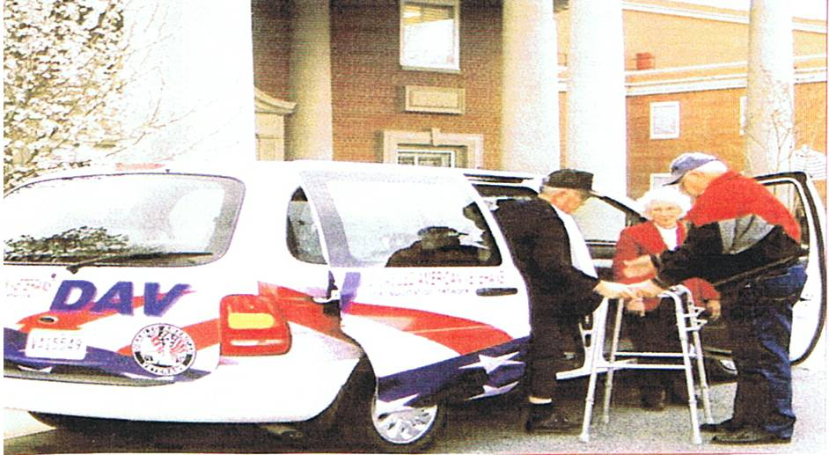

DAV, Dept of MD-Veteran of the Year
Chair – PDC Richard E. Bamberger

Chapters – Please submit your candidates for DAV, Dept. of MD – Veteran of the Year 2007-2008. Candidates should submit a biographical statement listing their military service, what they have done since they became a member of the DAV, what offices they have held as DAV Members (National/Department/Chapter levels), and whatever special recognition, citations, etc that they have received from National, the Department or their community.

Please send this information to:
Chair – PDC Richard E. Bamberger
2209 Pinefield Court
Waldorf, MD 20601
Email: reddiver@verizon.net if you have any questions, call PDC Bamberger at 410-335-7363

Disabled American Veterans Auxiliary
Betty Swift, State Commander

It is with sadness that I begin this report. We have lost a great friend and worker for the DAV in Lee Rencher. Lee’s work was just beginning as the Department Adjutant, we must all pull together to accomplish the work of our organization. Lee will be greatly missed.

The Auxiliary Past State Commanders are having a crab feast on September 15, at 1 p.m. at the Bowie Chapter Home. Tickets are $25.00 and can be purchased by calling Edith Hinds at 301-559-8729 or at the bar in Bowie. Reservations are available with a paid ticket. Show your support of the PSC by attending. Menu: crabs, fried chicken, potato salad, cole slaw, corn on the cob, soft drinks and beer. All you can eat, so eat until you ouch!

Chapter and Unit #26 is having a picnic at Solomon’s Recreation Center. It is under cover so the weather will not be a problem. Contact Bob or Ruth Wilcoxen for directions and more information.

The DEC/SEC meeting is to be held on October 9, 2007 at the American Legion Post #11, 1450 Taney Avenue, Frederick, MD 21702. The meeting is scheduled for 1 PM. Be early and arrive by 12 Noon. There will be articles to read and some Committee meetings to attend. Lets do all this before it is time to start the meeting.

Membership is always a main concern. Gentlemen did you know that you can be a member of the DAV and the Auxiliary at the same time. So – Sign up yourself, your spouse, your parents, your children, your siblings. Make our numbers grow.

Yours in Comradeship

Betty Swift
DAVA, State Commander

DAVA

National Service Office
Baltimore, Maryland

Hello DAV comrades!

We had a great National Convention, and it was great that I was able to attend meetings with some of my comrades from Maryland, especially with Commander Parker and NEC Forbes. They did a wonderful job representing our state.

It was also a time of sadness, after hearing about the passing of our Adjutant Lee Rencher. My prayers go out to his family and friends.

I would like to thank all of the CSO’s who have been calling in for assistance and guidance. No matter how busy we are, it is always a high point in the day to get a call from a CSO who has some questions concerning a vet they are helping. It feels good to know there are people out there who care and are not afraid to speak up and help a fellow veteran. Keep up the good work, and remember, we will always be ready to help you in any way we can.

After October, I would like to make it available for Chapter Commanders to ask for a NSO to come visit their Chapter and give an information seminar or just to meet our comrades from around the state. If something like this sounds interesting to your chapter, please contact my office so we can discuss the details of such a visit. It is always good to finally have an opportunity to meet and get to know each other better.

One last thing, please remember that the DAV does not charge for assisting a veteran in obtaining VA benefits, nor do we require payment if the veteran receives retroactive payment from the VA.

Respectfully,

Flip Micocci
National Service Officer

Mobil Service Office

9/8/07 – Harley Davidson
9407 Livingston Rd.
Ft. Washington, MD 10-4 PM

9/9/07 – Harley Davidson
10210 Gov Lane Blvd. # 2004
Williamsport, MD 11-4 PM

9/11/07 – VFW Post #467
519 Poole Rd.
Westminster, MD 11-4 PM

9/13/07 – AmVets Post #2
702 East South Street
Frederick, MD 11-6 PM

9/18/07 – Wal Mart Parking Lot
45485 Miramar Way
California, MD 10-4 PM

9/20-21/07 – Harriet L. Hunter Sr. Center
6420 Allentown Road
Camp Spring, MD 9-5 PM

9/23/07 – Harley Davidson
8845 Pulaski Hwy.
Baltimore, MD 8-5 PM

If you already are working with the DAV, National Service Office, it is better to call the DAV, NSO Office at 410-230-4440. The MSO truck is out there to meet new people and will not be able to check on a claim or anything for those who already have pending claims.



Support Our Troops All Over The World…

Remembering those who have given their all and those who are still in harms way.

Remember
Those who are serving now and those who have served
On
Veterans
Day.
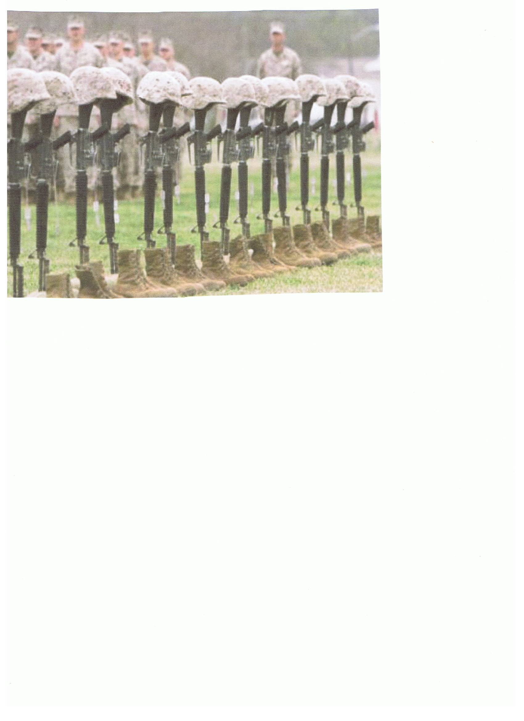

READ ALL ABOUT IT…

BAYSIDE AT FORT HOWARD

While all seniors have the opportunity to live in the community of Bayside, special emphasis is placed on serving those who have worked and fought to maintain our country’s freedom. Located on the historic Fort Howard campus, Bayside will offer a diverse selection of residence choices, lifestyle options, services, health care, and amenities, as well as a wide range of educational, cultural, and recreational activities. Planned in three phases, with the final phase scheduled for completion in 2012, it is anticipated that the first units will open in early 2008.

If you know a veteran or the widow/widower of a veteran who might be interested in living a Bayside, please let them know that an application package can be requested through any of the following methods:

- Call the Bayside at Fort Howard Customer Service Message Line at 1-866-698-9731
- Access the Bayside at Fort Howard website at www.baysidefthoward.com and complete the form under the “Contact Us” link
- Email the Bayside Customer Response Team at info@baysidefthoward.com

Alternatively, the application package can be downloaded directly from the Bayside at Ft. Howard website at www.baysidefthoward.com.

Chapter 13 - August 18, 2007 2nd Annual Auto Show at Golden Corral was held with 100 auto participation.


Mr. Clifford Stoffel, a members from Chapter 13, was Honored with the Presidential Volunteer Service Lifetime Achievement Award from Secretary of Veterans Affairs R. James Nicholson and VA Maryland Health Care System Director Dennis Smith for contributing more than 4,000 hours of service in the VA Maryland Health Care System as a Transportation Network Volunteer.

Congratulations to Billie Miles (Chapter 13 and Dept. Treasurer), who received a Congressional Citation for his continuation of Service to Veterans

Congratulations to Bob Mullenax (Chapter 13) who received a Congressional Citation for his many years of service to Veterans in Several Organizations.

When a Soldier comes home, he finds it hard…

..to listen to his son whine about being bored.

…to keep a straight face when people complain about potholes.

…to be tolerant of people who complain about the hassle of getting ready for work.

…to be understanding when a co-worker complains about a bad night’s sleep.

…to be silent when people pray to God for a new car.

…to control his panic when his wife tells him he needs to drive slower.

…to be grateful that he fights for the freedom of speech.
…to keep from laughing when anxious parents say they’re afraid to send their kids to camp.

…to keep from ridiculing someone who complains about hot weather.

…to remain calm when his daughter complains about having to walk the dog.

…to be civil to people who complain about their jobs.

…to just walk away when someone says they only get two week vacation.

…not to punch a wall when someone says we should pull out immediately.

…the only thing harder than being a Soldier is Loving One.

A gentle reminder to keep your life in perspective, and when you meet a returning Soldier, please remember what they have been through and show them COMPASSION AND TOLERANCE

(SEE PICTURES LISTED ACROSS, EACH PICTURE GOES WITH A LINE WRITTEN) – Sorry pictures are so small but I wanted to get them all in on the one page.

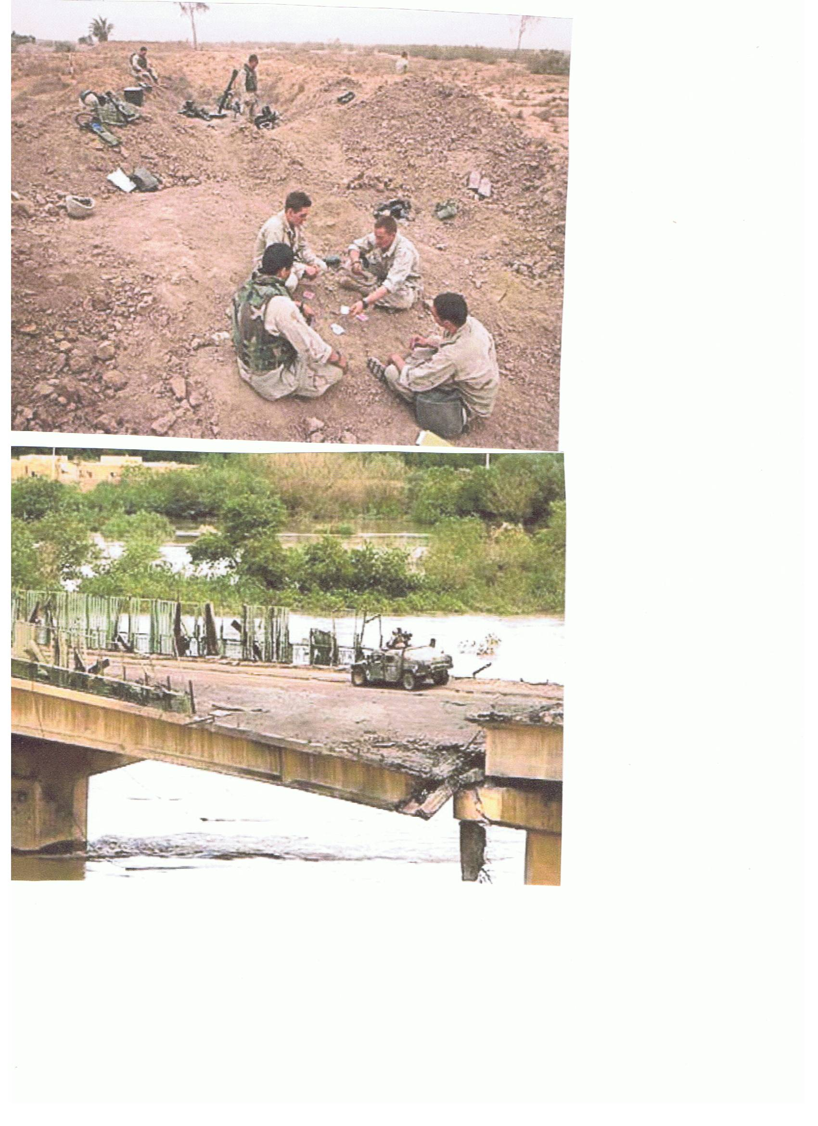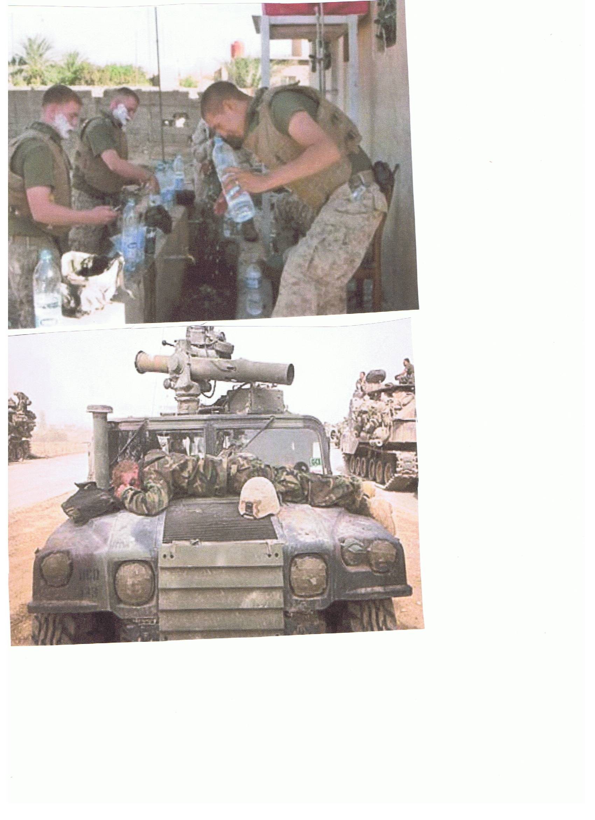
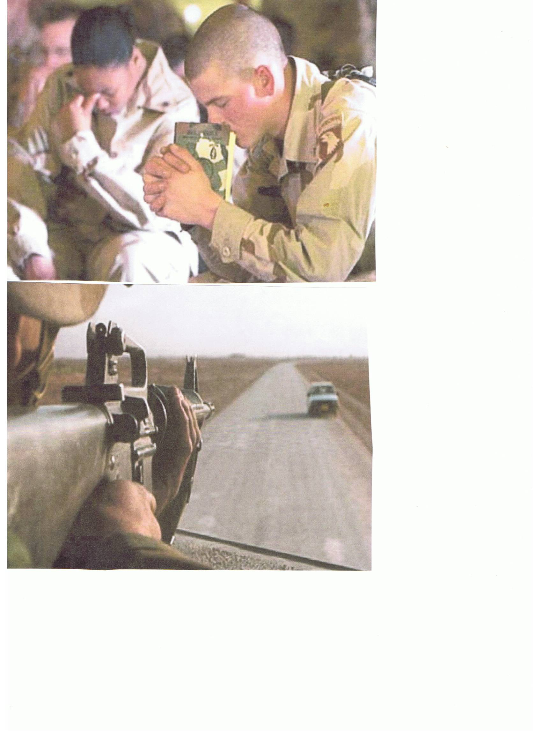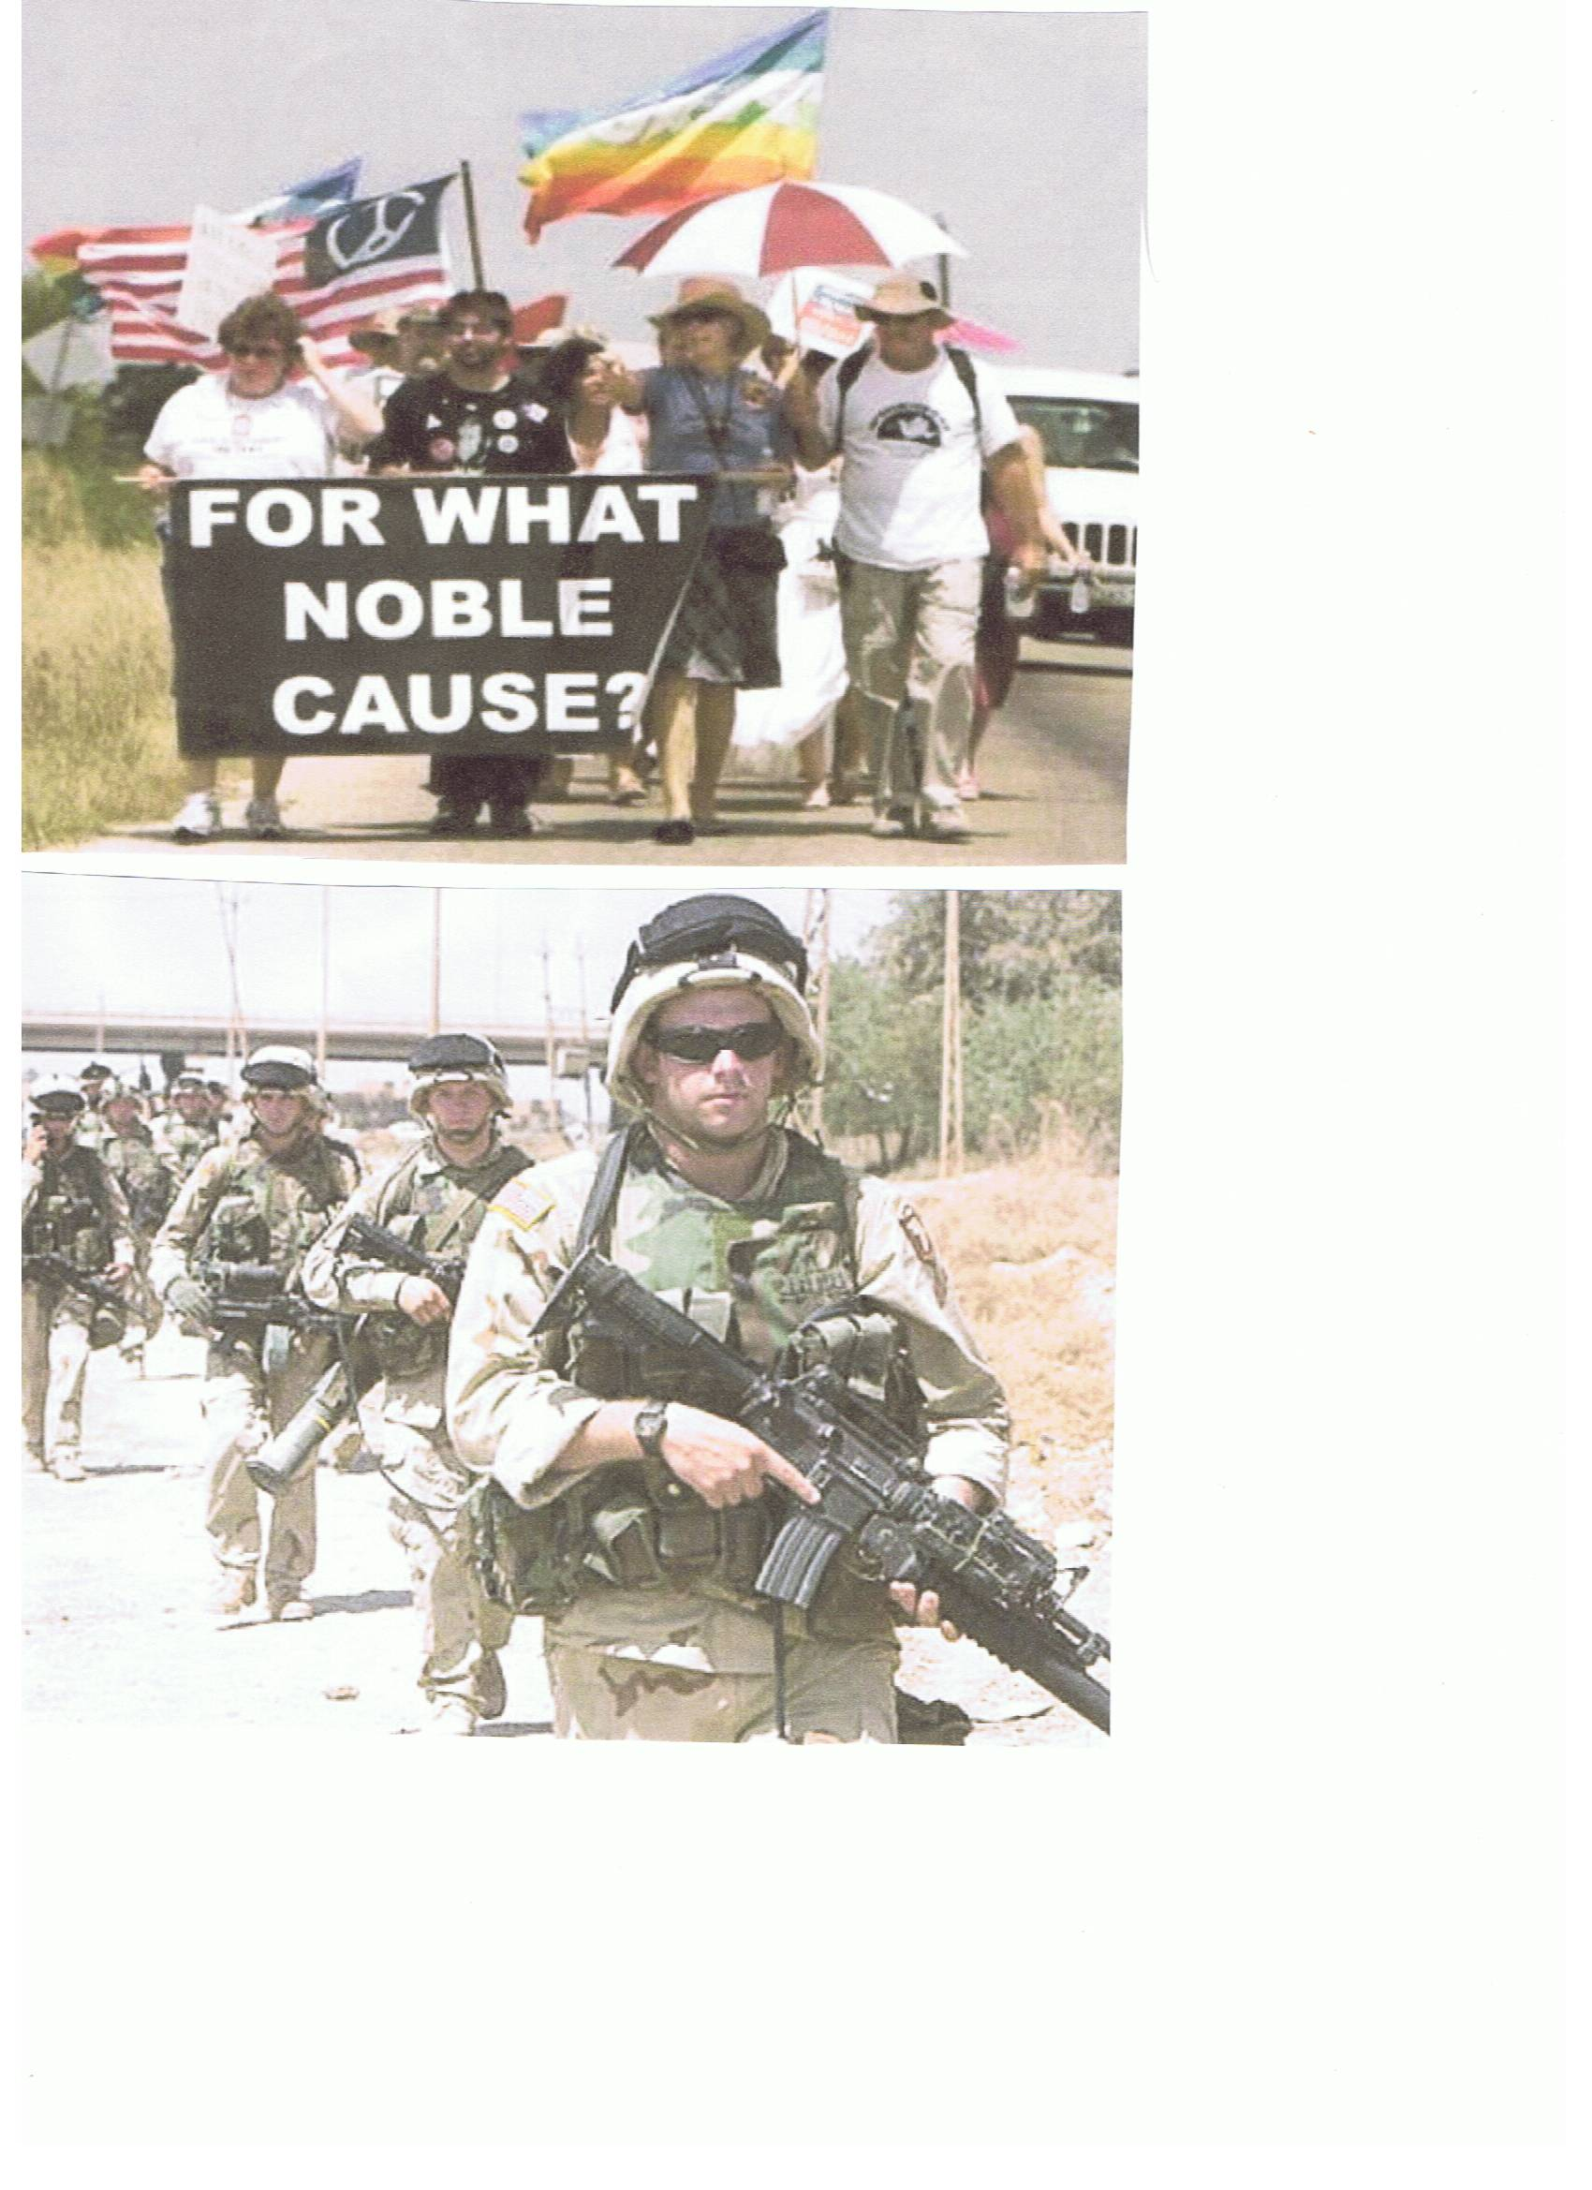
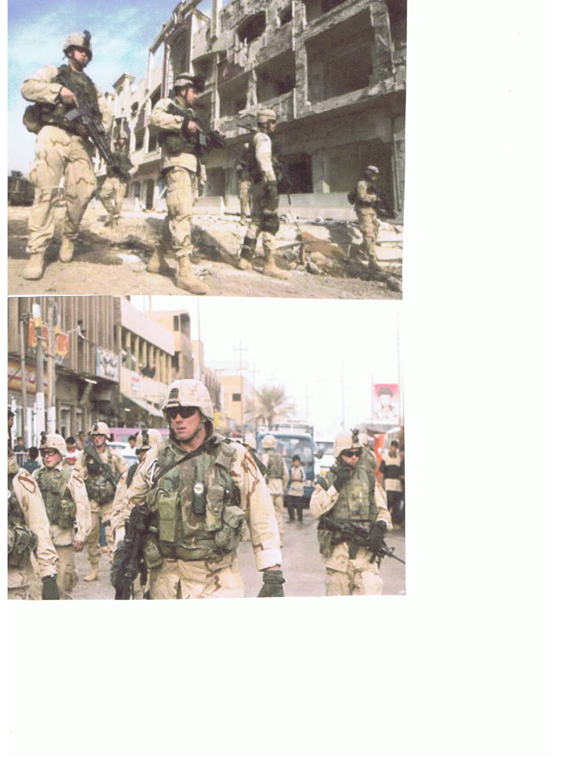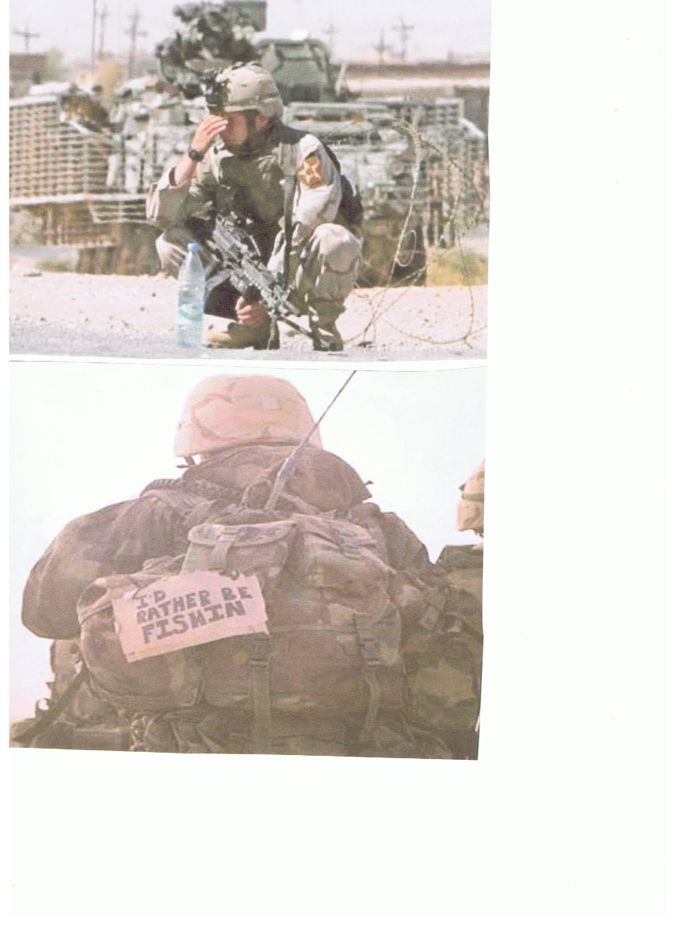
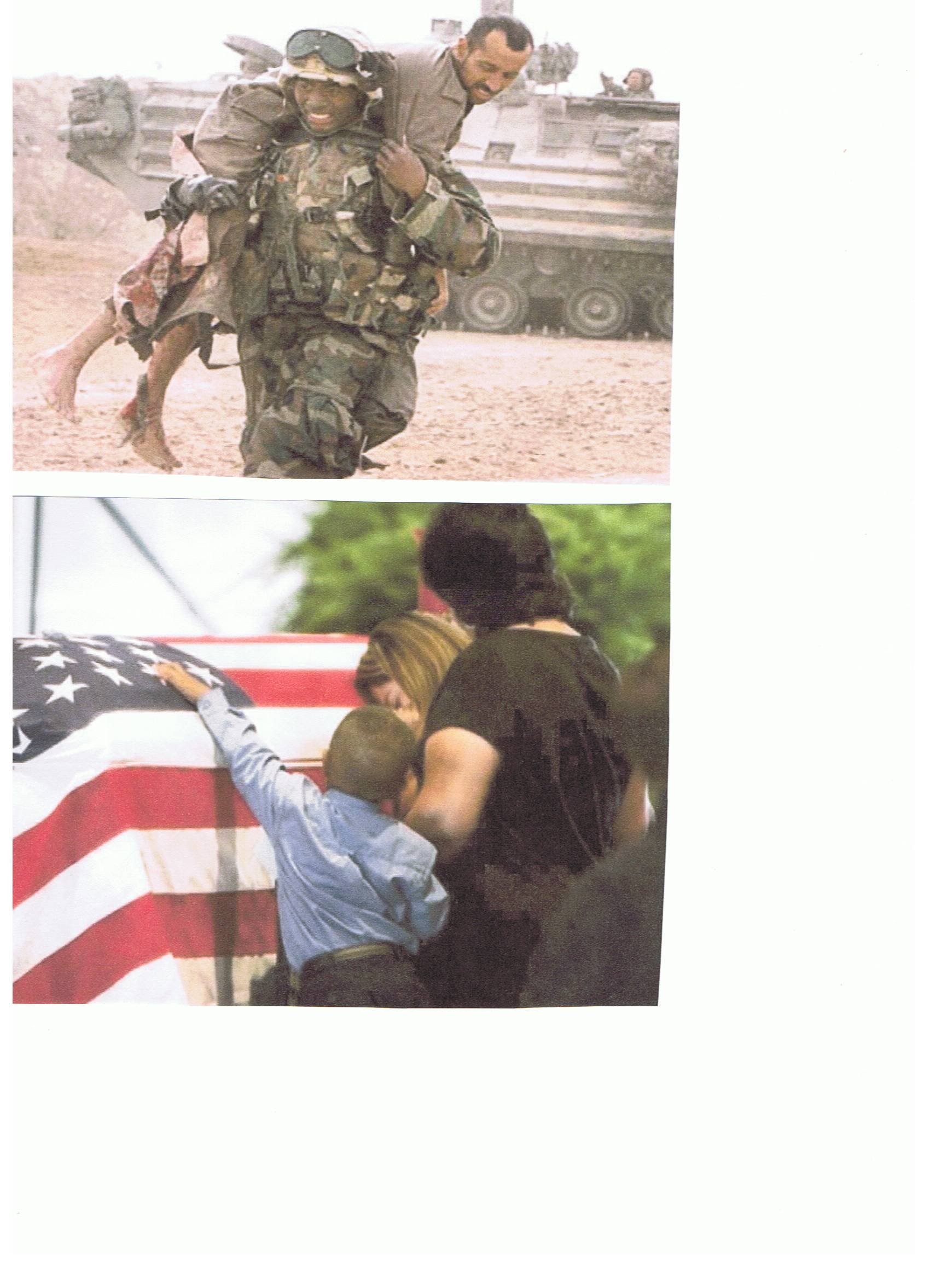
THANK GOD THEY ARE HOME.

ENJOYABLE TIDBITS:
(Jokes, poems, stories, sayings, etc.)

A Laugh a day; helps keep those Blues away……….
Logic

A Drill Sergeant was chewing out a new recruit when he asked him:
"Tell me stupid, if one of your ears was shot off what would happen?"
"Well sir, I couldn't hear."
"What if both your ears were shot off?"
"Well, I wouldn't be able to see."
"That is dumb. Why did you say that?"
"If both my ears were shot off, sir, My helmet would slide right down over my eyes!"

The Wild Kid
As a crowded airliner is about to take off, the peace is shattered by a 5-year-old boy who picks that moment to throw a wild temper tantrum. No matter what his frustrated, embarrassed mother does to try to calm him down, the boy continues to scream furiously and kick the seats around him.
Suddenly, from the rear of the plane, an elderly man in the uniform of an Air Force General is seen slowly walking forward up the aisle. Stopping at the flustered mother with an upraised hand, the white-haired, courtly, soft-spoken General leans down and, motioning toward his chest, whispers something into the boy's ear.
Instantly, the boy calms down, gently takes his mother's hand, and quietly fastens his seat belt. All the other passengers burst into spontaneous applause.
As the General slowly makes his way back to his seat, one of the cabin attendants touches his sleeve. "Excuse me, General," she asks quietly, "but could I ask you what magic words you used on that little boy?"
The old man smiles serenely and gently confides, "I showed him my pilot's wings, service stars, and battle ribbons, and explained that they entitle me to throw one passenger out the plane door on any flight I choose."



Hearing Problems
An elderly gentleman had serious hearing problems for a number of years. He went to the doctor and the doctor was able to have him fitted for a set of hearing aids that allowed the gentleman to hear 100%.
The elderly gentleman went back in a month to the doctor and the doctor said, "Your hearing is perfect. Your family must be really pleased that you can hear again."
The gentleman replied, "Oh, I haven't told my family yet. I just sit around and listen to the conversations. I've changed my will three times!"

